USTX prototype

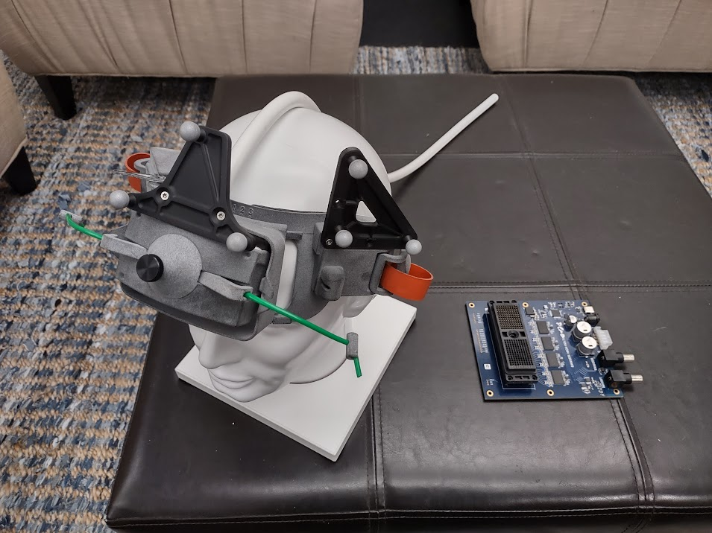

Figure 1

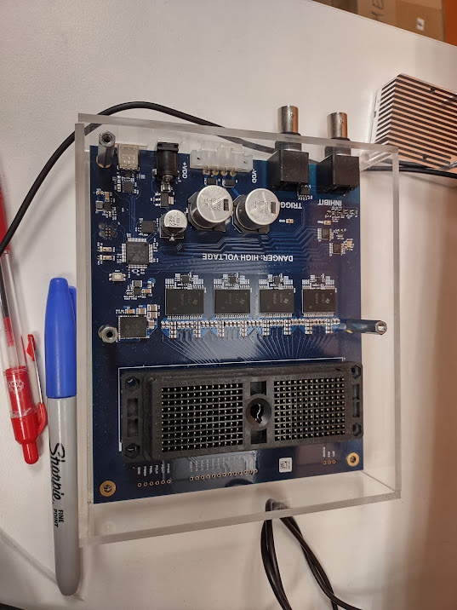

Figure 2

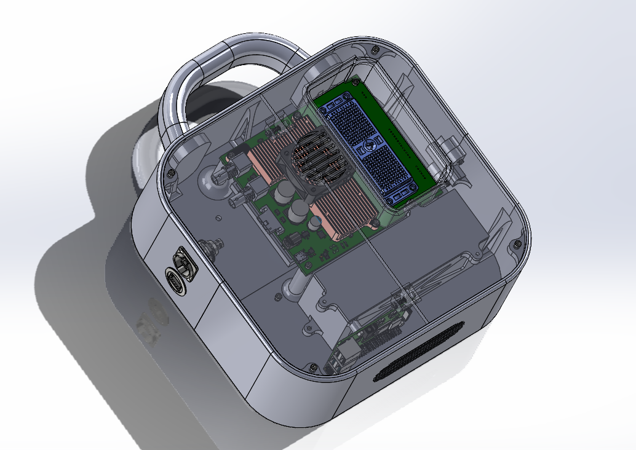

Figure 3

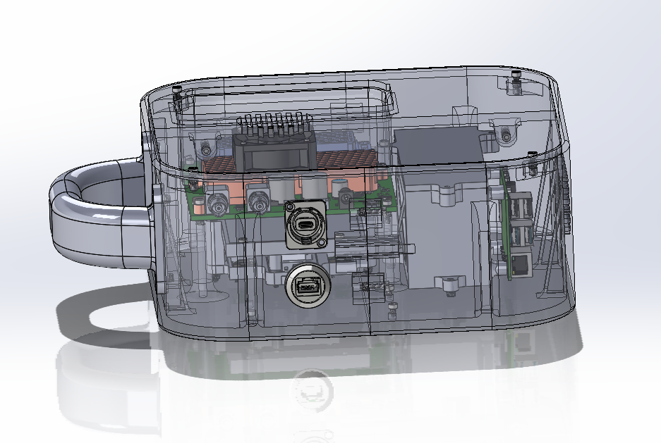

Figure 4

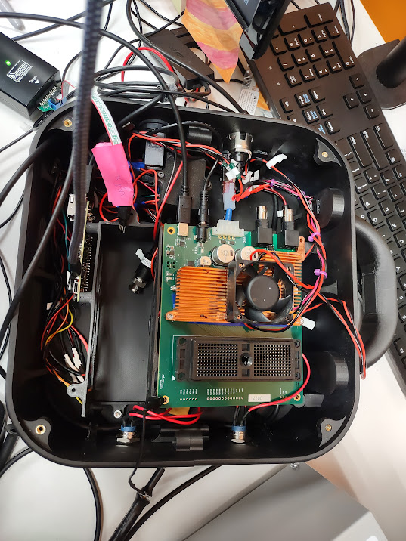

Figure 5 prototype

The USTX 1-2 .zip is the altium file download

Compact USTX driuper.zip is a compressed file with the native solidworks files

Compact USTX .step is a solid model of the assembly

Compact USTX.easm is a e-drawing or an assembly that can be opened with a free viewer